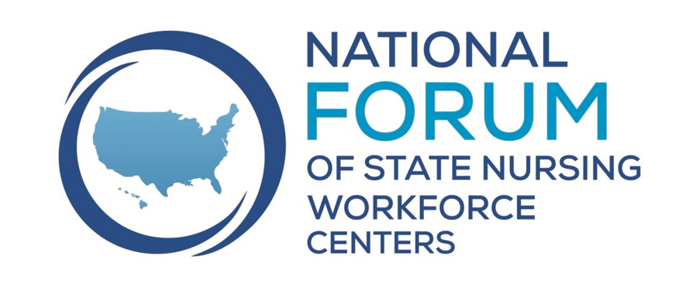
November Sharing Session:

Workplace Violence

November 17, 2023

Summary of Presentations

- Texas Center for Nursing Workforce Studies- see attached one-pager describing each program that also includes links to all programs.

Have been recommending that health care facilities have workplace violence prevention groups and this was passed as a requirement this summer through SB 240 at the 88th Texas Legislative session.

Workplace Violence Against Nurses Grant Program
They have a grant that was funded by legislative funding to provide grants to hospitals to implement workplace violence projects. The project goals include collecting data from nurses, informing patients and providing more security cameras. Impacts from the 2022 grant period included heightened attention to workplace violence, increased curriculum on workplace violence in nursing schools, event reduction, relationship between staff and security improvements and comfort in reporting and the development of a nurse support group. The reports from the projects are available on the Texas Center for Nursing Studies website.

Workplace Violence Against Nurses Employer Survey
Collect data through a survey that is attached to their employer surveys. The Survey asks about prevention programs/policies, reporting and tracking, workplace violence prevention training and strategies. Report from the 2022 survey is included on their website. Looked at changes from 2018 to 2022 through the COVID pandemic. Found that the most successful prevention strategies. Most use staff training, but this hasn’t been the most successful.

Workplace Violence Against Nurses Individual Nurse Survey
Are working on developing an individual nurse survey to ask about their workplace violence experiences, what has been the most successful prevention strategies, reporting requirements etc. Will compare with the employer surveys. Plan to launch in January 2024.

- Indiana Center for Nursing: Workplace Safety and Health Initiatives in Indiana- see powerpoint presentation for more details and links

Front-Line Nurse Focus Groups
Held a series of focus groups with 200 front-line nurses across the state and workplace safety came out as a primary need. Have developed some signage to emphasis this at health care facilities.

Safe and Sound Program: Indiana Hospital Association Violence Prevention Program
working to improve data collection, increase public understanding and working on legislation, provide training opportunities.

Eskenazi Health- there is a link to a 20-minute presentation in the powerpoint
Found an uptick of workplace violence and studied incident reports. Found that workers did a great job of filing out reports if it was physical violence but not as well if it was verbal abuse/violence. Developed a workplace violence committee and implemented several changes including badges with alert/location, security cameras, psych rapid response, panic buttons, training on situational bias, implicit bias, de-escalation, increase in awareness about reporting verbal abuse behaviors, started discussing all physical assaults at daily safety rounds, increased signage and metal detectors.

New Law Protecting Health Care Workers: House Bill 1021
Includes all staff members of an ER in the definition of “public safety official” which includes enhance penalties for battery.

Group Discussion:
- How is Texas accessing the individual nurses for your survey? Are obtaining the mailing address from the Board of Nursing and are mailing the surveys along with postcards to remind. The nurses complete the survey online or are able to complete it on the paper survey and mail back with the provided envelope.
- Louisiana has mailed out surveys through the Board of Nursing. Sometimes nurses are worried about the confidentiality and suggested making sure they know that their information will not be shared with the Board.
- For the signage that was deployed in Indiana. Did you have any reactions from the public or nurses? They haven’t officially studied it. Their focus groups nurses said that they have seen families of patients read the signs. They are right off of the elevator when they get on the floor. The patients are mostly curious about the signs and are wondering what is going on. Has served as a conversation starter. We didn’t used to talk about this, and our hospitals felt vulnerable about putting these signs up. We haven’t had any negative feedback. Important message.
- Any feedback from law enforcement? Indiana- Any incidents that have been reported to them directly and not to the health systems. Law enforcement has been on the committees but do not know if any of incidents have been reported to law enforcement. Texas has some data about the involvement of law enforcement- but do not know how often this is done.
- Maryland is looking at working with their hospital association to partner with them on this. This is one of the hospital association’s priorities. Looking at legislation and collecting data on how often this is occurring here.
- Georgia- have collaborated with the police department that comes to speak to pre-licensure nursing students at their college about de-escalation in these situations. Have started incorporating in med-surg the completion of the CDC online tutorial. https://wwwn.cdc.gov/WPVHC/Nurses/Course/Slide/Home Have also started bringing in a JD ombudsman to talk about conflict management and using the nursing process to treat conflict.
- Louisiana, law enforcement indicated that nurses are concerned about reporting, because they are concerned about having to go to the police department and the process after the report. One of the hospital’s allows them to use the hospital address as their address on the report rather than their home address. Working on crisis management and how to de-escalate situations. Sometimes there are concerns when dealing with a mentally ill patient- what do you do?
- How could we utilize law enforcement data? Our local police department has safety reports that they distribute. Would be great to send out a collective survey with law enforcement.
- Hawaii has started working on a healthy work environment. One of our facilities has a coffee with a cop to help healthcare staff have a direct relationship with law enforcement and help build trust. Are planning to disseminate this as a strategy to the rest of our state.
- There are also incidents of employee-employee violence. Has anyone worked on this?
- Massachusetts- we are also collecting violence data from all of our hospitals. Harder to get reports on more verbal violence. One of the hospitals have developed a QR code that is posted around the hospital to make it easy to report. Could be a report on a patient or another staff member. Are really working to make sure they respond the same day/next day and develop a care or other plan quickly. Have daily huddles and discuss all of the reports from the previous day. Staff is seeing that it really helping.
- Texas- many of our grantees talked about the culture. Have some questions about employee-employee violence on our survey. Many of the reports talk about the issues between employees and increasing a culture of collaboration. One of the facilities started doing nurse staffing meet-ups that were support groups and talked about all of the things that were making their days harder- difficult families, how the physician talked to them etc.
- The narrative in pre-licensure nursing programs is what will drive their expectations. They are leaving in 6 months due to workplace violence and are not tolerating this. The workplace needs to change to keep these employees. Have seen more zero tolerance for bullying and standard language about bullying. A lot of people talk about the work ethic of this generation- they have the power of numbers, and they are going to force change.
- This generation has watched their parents mistreated by their employers and don’t plan to repeat it.
- Bullying has been one of the most consistent concerns reported by newly licensed RNs in Louisiana on the Newly Licensed RN Survey.

