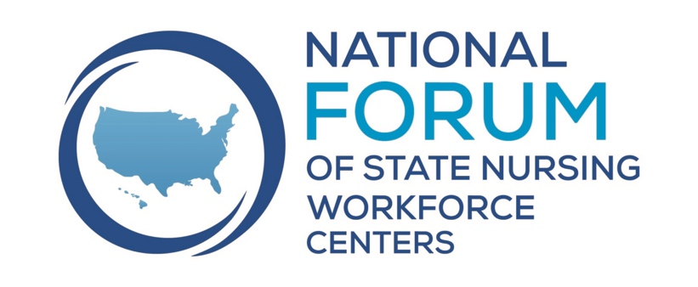
Monthly Sharing Session

Nurse Wellness and Retention

September 15, 2023

1:00 – 2:00 PM CST

Presentation Summaries

New Jersey Nursing Emotional Well-being Institute
  - Run monthly virtual Schwartz rounds with facilitators where nurses have a safe space to share their stories centered on a theme.
  - Stress First Aid- evidence-based, peer supported model for organizations to use in providing staff with skills to prevent and respond to stress, have sponsored nurses to become trainers.
  - Well-Being Hub- statewide learning collaborative and resource center for individuals and healthcare organizations. Online repository, learning collaborative/think tank, development of webinars and toolkits.
  - Nurse2NurseNH- peer support helpline
  - Communications- using social media to spotlight nurses what they are doing for emotional well-being
  - Also have Nursing Insights- nursing podcasts about nursing lives https://www.buzzsprout.com/2202543
  - Launching new nurse ambassadors/nurse influencers

Contact: Jennifer Polakowski jap518@sn.rutgers.edu and Susan Salmond
mailto:salmonsu@sn.rutgers.edu

More information: See attached powerpoint slides and website https://njnew.org/

Oregon RN Well-Being Project
  - Started from our Friday huddle- talk about what is going on in their workplaces and in their world.
  - Received funding to provide grants to organizations to develop interventions in their organization.
  - Received 32 applications and have funded the projects and they are all in the process of implementation. Half of the projects are in long-term care.
  - Have started seeing an impact of labor union issues on nurse well-being
  - Will develop a catalog of projects that work. They have to be organization level projects and not individual level.

Contact: Jana Bitton at jana.bitton@oregoncenterfornursing.org and Rick Allygeyer at rick.allgeyer@oregoncenterfornursing.org

More Information: Website: https://oregoncenterfornursing.org/rn-well-being-project/

Hawaii Nurse Well-Being
  - Started by adding questions to their licensure survey
  - Support a Statewide Nurse Residency Collaborative
  - Developing a Statewide Wellbeing, Recruitment and Retention Working Group with three priority focus areas: Creating a healthy work environment, Improving work schedule flexibility, implementing innovative care delivery models

Contacts: Laura Reichhardt lrnr@hawaii.edu and Carrie Olivera carrieol@hawaii.edu
Resources: See the attached powerpoint slides. Links are below:
https://www.hawaiicenterfornursing.org/wp-content/uploads/2021/12/2021-Nursing-Wellbeing-During-the-COVID-Pandemic-v.Final_.pdf
https://www.hawaiicenterfornursing.org/wp-content/uploads/2021/09/2021-COVID-19-Wellbeing-Infographic.pdf
https://www.hawaiicenterfornursing.org/wellbeing/
https://www.hawaiicenterfornursing.org/collaboratives/nurse-residency-program-nrp/

Group Discussion

- Maryland is launching a survey to nurse leaders and staff nurses about strategies in their organization that have been effective. Working with Lead Nursing Forward https://leadnursingforward.org/

- Is anyone focused on well-being of nursing students? New Jersey has trained several academic Stress First Aid trainers. Schools are starting to realize that their needs to be more of a focus on well-being. Some of the schools have added the Stress First Aid to their orientation.

- Colorado in our health sector partnership we have been working with employers and academics where they have embedded nurse well-being in the college curriculum.

- Hawaii is also working on training middle-managers to support nurse well-being in their environment.

- In response to a question about evaluation for programs- Hawaii’s Nurse Residency program has been around for 10 years. They are within employers so have limited data available. Have 12-month retention data. Have had difficulty gathering 24-month retention data. Will be collecting more information in the future.

- Washington- Washington has partnered with NCSBN and Dr. Linda Aiken at the University of Pennsylvania, to conduct a survey in Washington State. Washington was already planning to do a burnout and retention survey. The NCSBN/Penn survey will focus on a range of important issues, including the pandemic, workload, burnout, stress, staffing, and the Nurse Licensure Compact, among other topics. Other states include California, Florida, Illinois, Louisiana, New Jersey, New Mexico, Washington. Part of Nurses4All a longitudinal survey https://www.nursing.upenn.edu/chopr/nurses4all/

- Check out Sigbee. This app is already in place and let’s managers check in on their staff. Link to website

- North Dakota conducted a study pre-pandemic that focused on work environment. An interesting finding was that the biggest reason nurses wanted to leave their employer is their direct manager. They have been a great nurse and was promoted to that position- but didn’t receive any training on how to manage. Journal article citations below:

Owens, R., Moulton Burwell, Patricia & Petros, Thomas. (2022). Nurses’ and nursing students’ intent to stay: The impact of quality of life, work environment and work satisfaction. Nurse Management August 1; 53 (8): 34-43.

Owens, R., Moulton Burwell, Patricia, Deese, Stephanie & Petros, Thomas. (2021). Graduating Nursing Student and Practicing Nurse Perceptions on Promoting Recruitment, Work Satisfaction, and Intent to Stay: A Qualitative Study. Journal of Nursing Regulation, Volume 11, Issue 4, 1-10.

