Louisiana State Board of Nursing
Strategy Update Meeting Summary

November 30, 2021
po box 370156
west hartford, ct 06137
860.232.3667
www.theclariongroup.com

Table of Contents

Introduction 1
Overview of Strategic Effectiveness 1
Review of LSBN’s 2021-2023 Strategic Map 2
Review of Progress with Implementing the Strategic Map 4
Accomplishments with Implementing the Strategic Map 4
Implementation Issues/Gaps and Lessons Learned 5
Critical Issues – Next Two Years 7
Strategic Map Update 8
Central Challenge and Strategic Priorities 8
Strategic Mapping 8
Strategic Map for the Louisiana State Board of Nursing 9
Implementation Planning 12
Setting Implementation Priorities 12
Identifying Tracks of Work 12
Next Steps 13

Louisiana State Board of Nursing

Strategy Update Session

Meeting Summary: November 30, 2021

Introduction
Karen Lyon, Executive Director and Chief Executive Officer of the Louisiana State Board of Nursing (LSBN), welcomed participants to the strategic planning session and thanked them for their participation. Karen invited Laurie Schulte of The Clarion Group to facilitate the session.

Laurie outlined the day’s agenda:
- Review progress with implementing LSBN’s 2021-2023 strategic map.
- Update the map for the next year (calendar year 2022).
- Identify implementation priorities for the next year.

Overview of Strategic Effectiveness
The following is an overview of strategic effectiveness – an organization’s ability to set the right goals and consistently achieve them. Strategic effectiveness is the framework and philosophy within which we will update LSBN’s strategic plan.
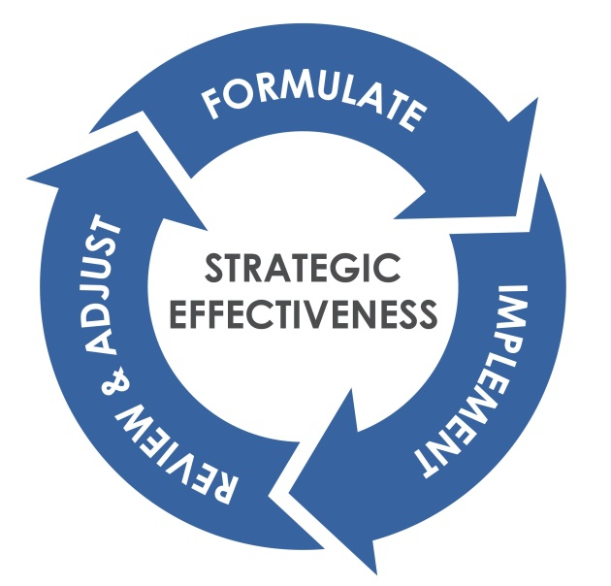

Organizations with high strategic effectiveness:
- Quickly formulate a “good enough” strategic plan.
- Move immediately to implementation – letting implementation teach them the ways that the strategy is on target and the ways it needs to be improved.
- Review progress on implementation regularly with honesty and candor.
- Make needed adjustments based on what is working, what isn’t, and how the world has changed.
- Focus on results, not activities.

Review of LSBN’s 2021-2023 Strategic Map
Using a one-page graphic representing a strategic map, Laurie reviewed the elements of the strategic map: central challenge, strategic priorities, and strategic objectives.
- The oval at the top of the strategic map is the central challenge.
  - It is the focal point for the strategy.
  - It focuses an organization on what it needs to do in the next three years to advance its mission and vision.
- The central challenge is supported by some number of strategic priorities. Strategic priorities are the few critical things an organization must do in order to meet its central challenge. The number of strategic priorities can vary, but it is never fewer than three or more than six.
- There are two tests of a strategic priority:
  - Is each priority necessary to meet the central challenge?
  - Are the strategic priorities taken together sufficient to meet the challenge?
- The boxes under each strategic priority are strategic objectives. Objectives spell out more specifically “what to do” in order to achieve the strategic priority.
Laurie reviewed LSBN’s current strategic map, developed in November of 2020 and reflected on the following page.
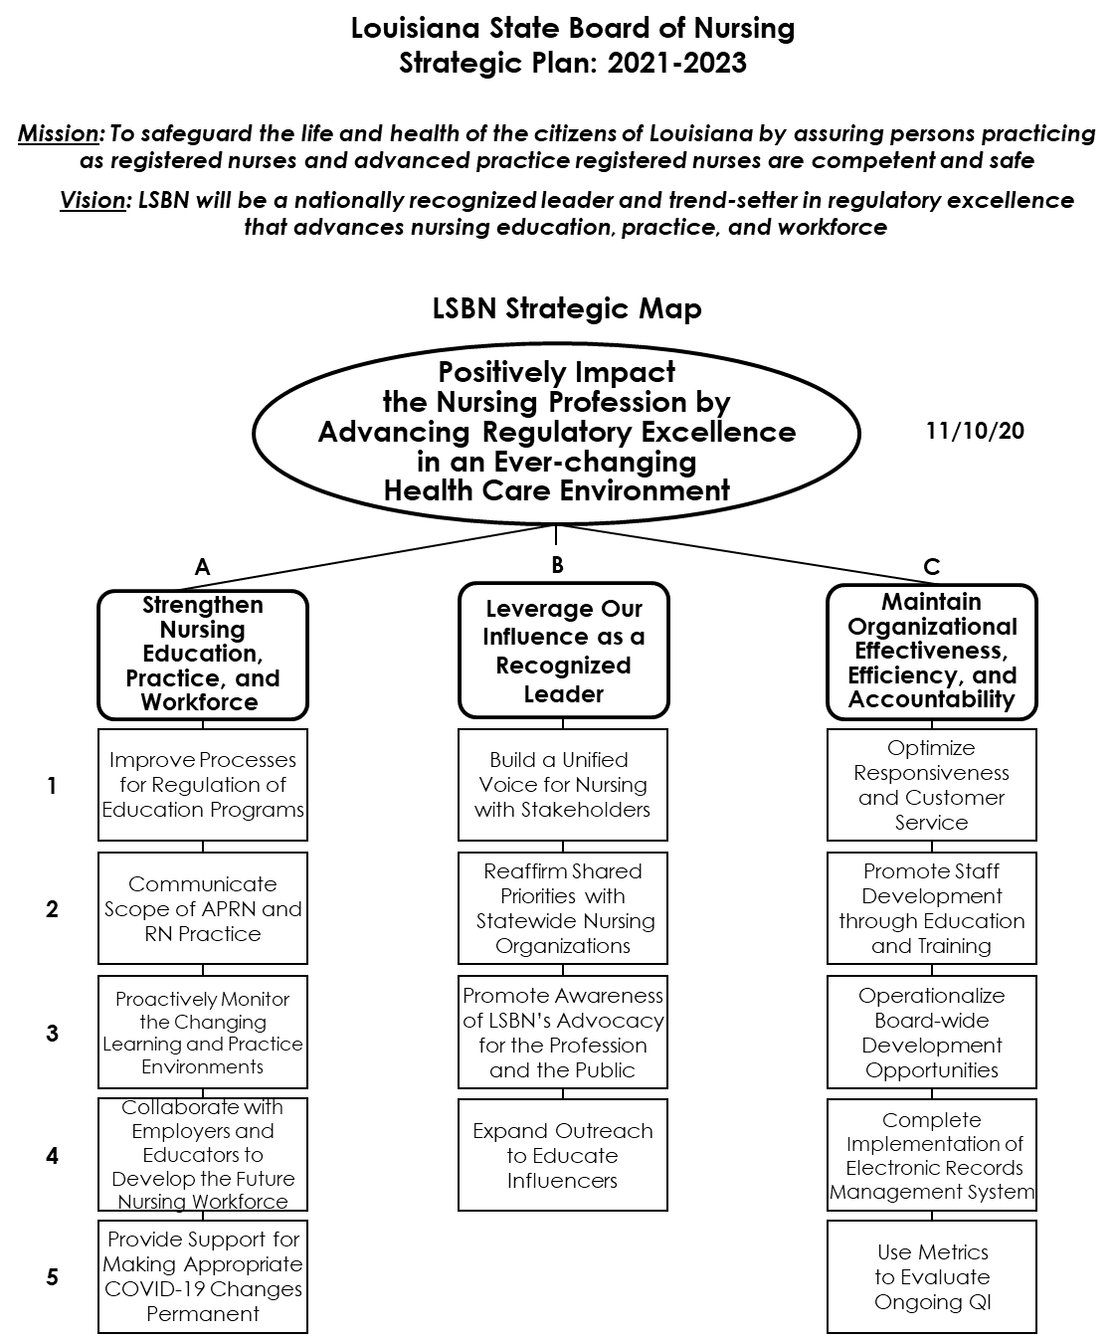

Review of Progress with Implementing the Strategic Map
Participants met in small groups to review progress with implementing LSBN’s current strategic map. They answered the following questions:
- What do you see as LSBN’s accomplishments with the implementation of its strategic map over the past year?
- What implementation issues or gaps did we experience? What did we learn?
- What are the critical issues facing LSBN over the next year?
A summary of the small group reports follows.

Accomplishments with Implementing the Strategic Map

Group 1 [Karen, Isonel, Terasita, Ken, Tim]

Strategic Priority A: Strengthen nursing education, practice, and workforce.
- Nursing students start careers earlier (COVID-19).
- Positive relationships with LSNA
- Advanced practice (full practice authority)
  - We achieved three of the four necessary steps/approvals in the legislative session.
  - LSBME offered to help write new language.

Strategic Priority B: Leverage our influence as a recognized leader.
- Significantly improved relationship with:
  - LSNA, LANP
  - Legislators
  - House/Senate committees

Strategic Priority C: Maintain organizational effectiveness, efficiency, and accountability.
- Improved customer service experiences
- Staff’s attitude towards customer service has improved.
  - Accountability
  - Remote work
- Examples of metrics accomplished:
  - Case closures
  - Applications/licensures
  - ACH payments
  - Paper-light accounting processes
- Redesigned website

Group 2 [Wendi, Tracy, Tavell, Mimi, Ann]
- Very pleased with progress in Strategic Priorities C and B
- Great progress with investigations
- Staffing changes, for whatever reason, appear to have been a positive.

Group 3 [Jennifer C., Carrie, Jennifer M., Wanda, Fredrick, Jennifer W.]

Strategic Objective A-4: Collaborate with employers and educators to develop the future nursing workforce.
- LACANE – speaking engagements, LSBN Board representative
- Virtual presentations at schools and facilities by LSBN Nursing and Compliance divisions
- Employers: support of the Governor’s mandate to get students into the workforce early
- Participate with advisory committees of educational programs, when invited.
  - CCME: every school is required to have an advisory board that meets twice a year.
  - Can LSBN reach out to established programs?
- Participation with NCSBN knowledge network for education
- Guidance for student residency program
  - Residency program educational module (which could be used at schools, as well)
  - The process of accreditation is set.
  - Every program has education hours.

Strategic Objective B-1: Build a unified voice for nursing with stakeholders.
- Conversations with the governor, legislature, Department of Health
- Dr. Lyon’s new Board member position with NCSBN

Strategic Objective B-4: Expand outreach to educate influencers.
- We are responsive in an emergency.

Strategic Objective C-1: Optimize responsiveness and customer service.
- New phone system for remote work
- Renewal: all hands on deck, giving staff tools to respond
- Grant: resources, communication
- Sister Lury scholarship communication

Strategic Objective C-5: Use metrics to evaluate ongoing QI.
- Part of PES
- Leverage ORBs reports
- Statistics/metrics provided in the new phone system

Implementation Issues/Gaps and Lessons Learned

Group 1

Strategic Priority A: Strengthen nursing education, practice, and workforce.
- Need more training of new graduates re: disasters, pandemic
- Retention and recruitment of workforce (faculty)
- Recruitment of new graduates/students
- Compliance with COVID vaccine mandates (ethical/religious issues)
- Student understanding of pandemics: “crisis standards”

Strategic Priority B: Leverage our influence as a recognized leader.
- WIIFM approach

Group 2

Strategic Priority A
- We need more nurses. Take a look at Ch. 35 for some flexibility:
  - BSN exemptions for faculty
  - Diploma nurses for clinical/preceptorships
  - Need more LPN to RN programs with flexibility in offering educational opportunities
- APRN programs
  - Out-of-state preceptors need to be held accountable to secure clinical placements for their students.
  - A need for practice education as part of the out-of-state program
  - Program input form – why are we doing it and do we need to continue?
  - (Some?) On site/face-to-face needs to be required
- As the practice of nursing continues to evolve, how do we stay ahead of issues? What is the mechanism by which we do so?

Strategic Priority C
- Board members need clarity on their roles, ongoing training, and access to all training LSBN conducts/hires (e.g., any “staff” training is also available to Board members)

Group 3

Strategic Objective A-4: Collaborate with employers and educators to develop the future nursing workforce.
- We need to touch on the next generation NCLEX.
- COVID: getting people in the workforce as opposed to developing the workforce
- Education guidance is too prescriptive.
  - Look at outcomes of education efforts: is there a better model to support and be less prescriptive?
  - Texas has a great model re: what a state nursing board does vs. what accreditation prescribes.
- Annual report: are we collecting data that is used? (It’s time consuming.)
- Pilot questionnaire by NCSBN
- Elevate the questions asked of/by the LSBN Board.

Strategic Objective B-4: Expand outreach to educate influencers.
- A lot of our work has been reactive.
  - Full practice authority
  - Educators

Strategic Objective C-5: Use metrics to evaluate ongoing QI.
- Not all tasks can be captured.
- Metrics aren’t always fair.
- Crisis of workforce is not always a regulatory role.
- ICRS: self-study opportunity

Critical Issues – Next Two Years

Group 1
- N/A

Group 2
- Impact of COVID-19 on the workforce; will there be an increase in complaints and violations?
- Full practice authority
- Disinformation from nurses
- New examination/education director onboarding
- Social media presence for LSBN? Other boards do.

Group 3

Strategic Objective A-4: Collaborate with employers and educators to develop the future nursing workforce.
- Do employers and educators feel like they have been collaborated with?

Discussion of the review of progress with implementation included the following points.
- LSBN staff, enabled by strong Board support, should be proud of its accomplishments over the past year.
- The LSBN Board – individually and collectively – would like more formalized/ “operationalized” training. This should include:
  - Onboarding
  - Role clarity/codification
  - Board competency
    - What is needed?
    - What gaps exist?
    - The Board agreed to complete an annual Board evaluation – of the collective Board, and self-evaluation for individual Board members. Isonel will work with Board Source to identify an approach and instrument.
  - “Hot topics” such as legal, regulatory, etc., as a regular part of in-person Board meetings
- Succession planning is a gap in the current strategy. This is relevant as individuals plan for retirement, as well as in anticipation of, albeit unlikely, an incapacitating event.

Strategic Map Update

Central Challenge and Strategic Priorities
Participants reviewed LSBN’s current strategic map and considered what changes, if any, needed to be made to the central challenge and strategic priorities. After discussion, the group agreed that the current central challenge and strategic priorities should continue as they are currently written.

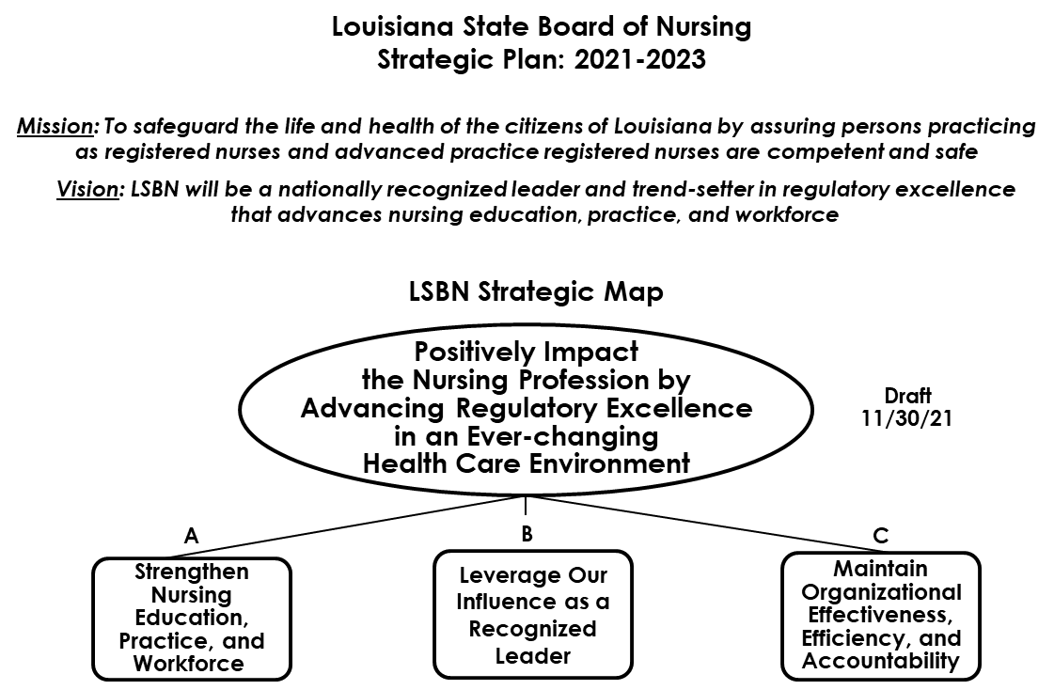

Strategic Mapping
Using the current strategic map as a starting point, participants worked in small groups to identify strategic objectives that support their assigned strategic priority. Groups considered:
- What strategic objectives should remain the same?
- What should be edited?
- What can be deleted?
- What, if anything, should be added?
A summary of the small group reports follows.

Strategic Priority A: Strengthen Nursing Education, Practice, and Workforce [Ed, Tim, Isonel, Teresita]
- Retain Strategic Objective A-1, “Improve processes for regulation of education programs.”
- Retain Strategic Objective A-2, “Communicate scope of APRN and RN practice.”
  - Add “educate” in the implementation of this objective.
- Revise Strategic Objective A-3 from “Proactively monitor the changing learning and practice environments,” to “Monitor and proactively respond to the changing learning and practice environments.”
- In Strategic Objective A-4, “Collaborate with employers and educators to develop the future nursing workforce,” replace “employers and educators” with “stakeholders.”
- Retain Strategic Objective A-5, “Provide support for making appropriate COVID-19 changes permanent.”

Strategic Priority B: Leverage Our Influence as a Recognized Leader [Tracy, Tavell, Wendi, Ann, Mimi, Karen]
- Revise Strategic Objective B-1 from “Build a unified voice for nursing with stakeholders,” to “Build a unified voice for nursing with key policy influencers.”
- Modify Strategic Objective B-2 from “Reaffirm shared priorities with statewide nursing organizations,” to “Reaffirm shared priorities with national and statewide professional organizations.”
- Retain Strategic Objective B-3, “Promote awareness of LSBN’s advocacy for the profession and the public.”
- Delete Strategic Objective B-4, “Expand outreach to educate influencers,” as it is duplicative with the revised Strategic Objective B-1.

Strategic Priority C: Maintain Organizational Effectiveness, Efficiency, and Accountability [Jennifer M., Jennifer C., Jennifer W., Wanda, Fredrick]
- Retain Strategic Objective C-1, “Optimize responsiveness and customer service.”
- Add LSBN’s Board to Strategic Objective C-2: “Promote Board and staff development through education and training.”
- Delete the former Strategic Objective C-3, “Operationalize Board-wide development opportunities,” as it is considered to be subsumed within the revised Strategic Objective C-2.
- Add a new Strategic Objective C-3: “Develop a Board member and Board evaluation process.”
- Retain Strategic Objective C-4, “Complete implementation of electronic records management system.”
- Retain Strategic Objective C-5, “Use metrics to evaluate ongoing QI.”

Strategic Map for the Louisiana State Board of Nursing
Based on the above input and discussion that followed, the group updated the LSBN strategic map as shown on the following page.

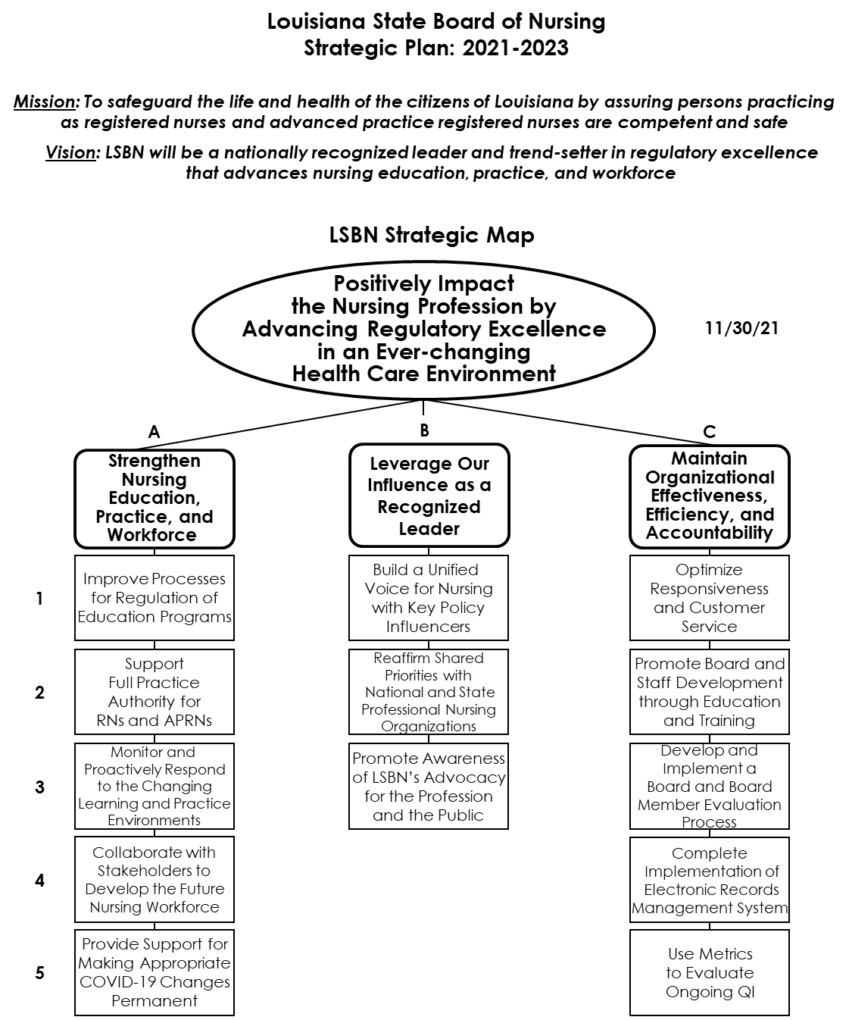

Highlights of the relatively brief discussion follow.
- LSBN’s Board has become more adept at this work; its strategy has become more focused since the first iteration of the LSBN strategic map (developed in November 2017).
- The updated strategic map changed very little compared with the version developed a year ago.
- The group discussed whether nursing education has kept pace with increases in acuity over the past decades.
  - For those nurses who receive their clinical training in metropolitan area hospitals, the answer is yes.
  - Rural areas often have not kept up. Clinical sites in rural areas do not treat the types of complex patient issues that those in metro areas see regularly.
  - The burden of clinical training falls on the clinical setting; who they are and what they can do determine the breadth and depth of nurse clinical training.
  - Transition to practice programs for newly hired nurses are critical, among other reasons, to fill this complexity gap.
- Nursing education will have to change to keep up with burgeoning home health.
  - Partnerships are required to keep educators apprised of what practitioners need.
  - By understanding where and how the partnerships are taking place, LSBN can help match underserved schools with partner providers, so that nurses are adequately prepared for their post-education clinical settings.
- The results of the recent nursing graduate survey will provide useful feedback on these issues, as will the upcoming “Synergy Summit,” at which nurse educators and providers will meet to consider deepening their relationships.
- With support from providers and educators, LSBN has a role to play in “lifelong learning” for nurses.
- In discussing Strategic Objective A-2, “Support full practice authority for RNs and APRNs,” the following points were made.
  - “Scope of practice,” the language used in the prior strategic map, can be problematic, especially with the legislature. “Full practice authority” is preferred, as:
    - Scope of practice is defined by statute relative to the level of education, training, and experience earned. There must be room for this scope to expand as a nurse pursues additional education and training. If a nurse could practice only to the extent of her/his initial degree/diploma, professional growth would be limited.
    - Practice authority has an educational component, for example, when an RN goes to graduate school or an LPN pursues a BSN.
  - As defined by the IOM in its first Future of Nursing report, the authority is conferred on those who choose to practice with that level of independence. LSBN supports those who choose not to, as well.
- In Strategic Objective B-1, “Build a unified voice for nursing with key policy influencers,” key policy influencers include non-nursing professional organizations such as LHA, AARP, Home Health Association, Nursing Home Association, etc.
- In Strategic Objective B-2, the addition of the word “professional” nursing organizations refers to those organizations who are involved with RNs and above. This excludes the LPN Board, albeit without malice; the LSBN’s Board does not interact with LPNs at this point in time.

Implementation Planning

Setting Implementation Priorities
The group surveyed perceptions of which objectives on the strategic map are the most important to emphasize during the next 12 months. Each person was given four votes, and a summary of the “straw vote” is depicted in the table below.

 | A | B | C
1 | 1 | 8 | 3
2 | 12 | 5 | 5
3 | 6 | 1 | 5
4 | 9 | X | 3
5 | 1 | X | 4

This “straw vote” will provide guidance on the most important things for LSBN to focus on as it proceeds with implementation planning for the second year of its three-year strategic map.

Identifying Tracks of Work
Laurie introduced the group to the concept of a track of work.
- A track of work is a single map objective or a group of related objectives that uses the same resources.
- Tracks of work are a means of getting organized for implementation.
- Organizations generally focus on no more than three to five tracks in a 12-month implementation period.
Participants agreed that the following tracks of work should receive primary emphasis during the next 12 months.

Support Full Practice Authority
- Strategic Objective A-2: Support full practice authority for RNs and APRNs.
- Strategic Objective B-1: Build a unified voice for nursing with key policy influencers.
- Strategic Objective A-5: Provide support for making appropriate COVID-19 changes permanent.

Workforce/Transition into Practice
- Strategic Objective A-4: Collaborate with stakeholders to develop the future nursing workforce.
- Strategic Priority B: Leverage our influence as a recognized leader.

Board Development
- Strategic Objective C-3: Develop and implement a Board and Board member evaluation process.
- Strategic Objective C-2: Promote Board and staff development through education and training.

Respond to the Practice Environment
- Strategic Objective A-3: Monitor and proactively respond to the changing learning and practice environments.

Next Steps
At the conclusion of the meeting, the group identified the following next steps.
- The Clarion Group will provide the following written deliverables to Isonel Brown for distribution to participants:
  - A final version of the strategic map
  - A “presentation version” of the strategic map
  - This written summary of the strategic planning session
- LSBN will pursue communications and implementation planning in a manner similar to what it has done in the past. Laurie Schulte is happy to provide whatever guidance is needed as LSBN continues to implement its strategy.

