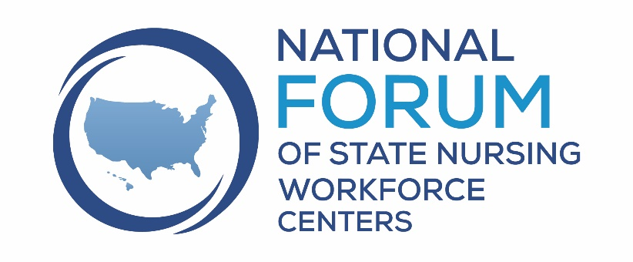
Sign on as a Co-sponsor for the bi-partisan, bi-cameral, National Nursing Workforce Center Act.

https://nursingworkforcecenters.org

Who are we?
The National Forum of State Nursing Workforce Centers (the Forum) are a group of 40 state nursing workforce centers that focus on addressing the nursing shortage within their states and contribute to the national effort to meet the health needs of the US population with an adequate supply of qualified nurses.

What do we do?
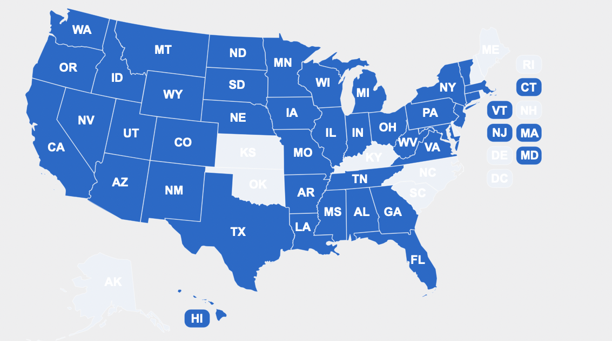
The Forum supports the advancement of new and existing nurse workforce initiatives by sharing best practices in nursing workforce research, workforce planning, workforce development, and the formulation of workforce policy.

Why are state nursing workforce centers important?
Federally-supported institutions, such as the National Advisory Council on Nurse Education and Practice, National Center for Health Workforce Analysis, and Health Workforce Research Centers, research and advise on policies related to the national healthcare workforce. While these entities inform health workforce planning and policy at a national level, the needs of communities differ significantly across the country. Policies developed based on national data may not always make sense for individual regions, states, or local jurisdictions.

State nursing workforce centers fill this gap. Nursing workforce centers are hubs that advance nursing education, practice, leadership, and workforce development at the state and local levels using data-driven approaches. Services of a nursing workforce center typically include: conducting localized research; publishing reports related to supply, demand, and educational capacity of the nursing workforce; and implementing other activities to improve the nursing workforce in their states.

How do we impact the nursing shortage?

Since every state needs an individual approach to influence the nursing shortage, state nursing workforce centers implement evidence informed strategies to make the biggest impact. For example, individual state nursing workforce have addressed the nursing shortage by:

Studying the unique characteristics state nursing workforce
- Gather data on supply, demand and educational pipeline of nurses (24 states).
  - Explore regional and workplace setting differences to inform solutions (Oregon).

Increasing the number of new nurses
  - Collect data and testing solutions to nurse faculty shortages (California, Connecticut, Hawaii, Idaho, Indiana, Louisiana, New Jersey, New York, Washington, and Wisconsin).
  - Address inefficiencies in clinical experience scheduling and advocate for new clinical sites (California, Colorado, Connecticut, Hawaii, Idaho, Indiana, Maryland, Mississippi, New Jersey, Washington).
  - Predict the need to increase nurse production which resulted in funding to more than double the students enrolled in nursing schools (North Dakota and Oregon).
  - Coordinate scholarship programs (Colorado, Illinois, Indiana, New Jersey, New Mexico, New York, North Dakota, Pennsylvania, and Vermont).

Recruiting nurses to the profession
  - Create programs to increase interest and awareness of nursing to K-12 students (Arkansas, Colorado, Hawaii, Indiana, Mississippi, North Dakota, Washington).
  - Build programs to diversify their nursing workforce including mentoring programs (Arkansas, California, Colorado, Connecticut, Illinois, Indiana, Louisiana, Michigan, Mississippi, New York, Pennsylvania, Washington, and Wisconsin).

Retaining nurses in the workplace
  - Ensure the well-being of the nursing workforce and improve workplace environment (California, Colorado, Hawaii, Idaho, Indiana, Maryland, Mississippi, New Jersey, North Dakota, Pennsylvania, South Dakota, Washington, and Wisconsin).
  - Create training opportunities for nurses at all levels and in all settings to advance leadership and professional practice (Arkansas, California, Colorado, Connecticut, Hawaii, Illinois, Indiana, Louisiana, Maryland, Mississippi, Montana, New Mexico, North Dakota, Pennsylvania, Washington, and Wisconsin).
  - Promote continual learning and academic progression for nurses (Arkansas, California, Colorado, Connecticut, Hawaii, Indiana, Maryland, Pennsylvania, and Washington).

Advocate for changes to improve the stability of our state’s nursing workforce
  - Provide critical employer- education connections through statewide planning and implementation of programs (Colorado, Connecticut, Indiana, North Dakota)
  - Leverage connections through state nursing stakeholders to pass critical legislation such as Nurse Licensure Compacts and respond to the future needs of the nursing workforce needs following the COVID pandemic (Louisiana, North Dakota, Oregon, Louisiana, West Virginia, Arkansas).

As the only connector of state nursing workforce centers, the National Forum of State Nursing Workforce Centers serves a critical role of sharing best practices and providing technical support to help
nursing workforce centers thrive.
For More Information:
Patricia Moulton Burwell, PhD, Director, National Forum of State Nursing Workforce Centers
info@nursingworkforcecenters.org

