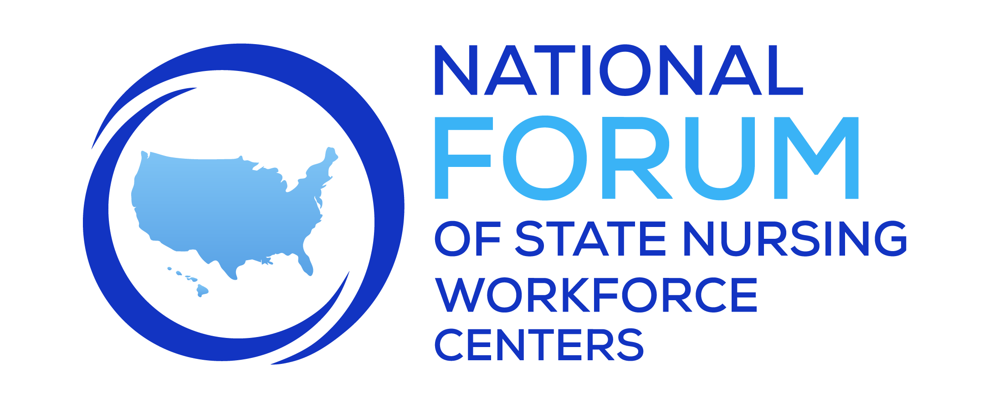

January Sharing Session

Legislation and Other Issues

Participants: Jane Mahowald, Ashley Badders, Katie Gaul, Meggin Lorino, Linda Roberts, Jason Ritchie, Lanelle Weems, Patricia Moulton Burwell, David Armstrong

Ohio: Ohio has joined the compact as of January 1st. The new administrative rules have been released. Click to find the new Rules in Ohio
Ohio does not have funds allocated to analyzing licensure data. It is posted online at the Ohio Board of Nursing website.

New York: Passed legislation a year ago mandating workforce data collection for all health
care professionals in the state. There wasn’t any money attached, but an RN survey was launched and plan to incorporate an LPN survey. It is an online survey that is required before they can complete their licensure renewal.

Washington: Has a requirement that all nurses complete the e-notify survey upon licensure
renewal, however, not sure how many actually change their information each time. The state is working on developing a system for all health providers for standardized data collection at licensure renewal called HELMS https://doh.wa.gov/licenses-permits-and-certificates/healthcare-enforcement-and-licensing-management-system-helms
There is a push to increase the salary for University nursing faculty as the Community College faculty received salary increases during a previous legislative session and this has created issues within WA.

South
Carolina: Are asking for additional funds in their AHEC funding appropriation to expand to offer a nursing workforce center.

For FY23, the state appropriated $10M to support nursing faculty. $5M was to support current clinical nurse faculty salaries, and $5M was to financially support students in graduate nursing programs who commit to becoming faculty. Can be carried forward to next fiscal year. https://che.sc.gov/che-data-and-reports/2022-higher-education-nursing-initiative

Illinois: The state has indicated that it won’t criminally charge patients or providers seeking abortion services in Illinois. Providers would still have to be licensed in Illinois and there is a temporary permit available. There are some new clinics setting up along the Missouri border.

Planning to copy the Washington Data Snapshots now that they have data on LPNs, RNs and APRNS. Have had a scholarship for LPNs, RNs and have added for graduate students that want to become a nursing faculty. Have had a faculty salary stipend that is funded by state appropriations: https://www.ibhe.org/grants/nefp/FY23_Nurse_Educator_Application_Packet.pdf

Mississippi: The Governor is trying to get more support for our nursing education programs. Working on getting a nurse loan repayment bill for nurses that work in our state. Trying to get more funding to our hospitals other than Medicaid expansion- the Governor has said he will veto anything related to Medicaid expansion.

ANA: Working on safe staffing, workplace violence and are having advocacy institute soon.

New Mexico: There is some legislation that the Nurse Anesthetists are working on to expand their scope of practice.

