The Twelve Types of Boards

What type of Board(s) do you have at your Center?

Are you and they prepared for change and ready to undertake their mission?

Some Do and Most Don’t Board  First, there’s the “Some Do and Most Don’t” board. This type of board may have twelve (12) to eighteen (18) members on it, but philanthropy (giving and getting) is limited to three (3) to four (4) members who have the capacity to do good. Unfortunately, the burden of carrying the ball falls on the shoulders of these few, which doesn’t portend well for the nonprofit. | We Have Never Done This Before Board  Then there is the “We Have Never Done This Before” board. OMG! This type of board may have well-intentioned folks serving on it, but members have no resource development history or philanthropic capacity. The nonprofit won’t stand a chance to evolve and grow, because its finances and fundraising future are limited.
I’m Not a Fundraising Type of Guy Board  The third type is “I’m Not a Fundraising Type of Guy” board. There may be folks here with philanthropic ability, but they have no desire or willingness to undertake their fundraising duties. It is hard to make forward progress unless one can change these board members’ inclinations. | All Aboard Board  The “All Aboard” board is a large group—maybe forty-five (45) to fifty (50) members—with twelve (12) to fifteen (15) proactive donors and ambitious people. Certainly, it benefits the organization having active board members, but a larger group can be cumbersome and needs specific fundraising guidance.
Not Quite Prime Time Board  Some nonprofits have the “Not Quite Prime Time” board with a heavy concentration of mid-level corporate and community leaders. These folks have great potential, but need leadership training to help them maximize their potential. | Good Talent Pool Board  A sixth board is the one with “A Good Talent Pool.” This is a desirable board to have because there is a good mixture of balanced talent distributed to working committees, with fundraising consigned to a specific committee.
No Dinero Board  Of course, many of us are quite familiar with the “No Dinero” board. You will often hear them say, “We give our time and talents,” and have respectable people on it. But they don’t give! Not helpful because a balance of giving and talent is essential. | An Evening of Reruns Board  You may have seen the “An Evening of Reruns” board. This board is constituted of the old guard who describe themselves as “tired and tapped out.” Usually, they have no term limits and, historically, have a noticeable absence of younger members. Just not helpful.
What Kind of Wood Are We Using for the Fence Board  Senior executives are very acquainted with the “What Kind of Wood Are We Using for the Fence” board. This is a board that exists to oversee the staff and, quite often, micromanages the organization. Frankly, if you hire a competent professional and competent staff, this type of board can be quite counterproductive to the best interests of the organization. | My First Commitment is to My Alma Mater Board  Then there is the “My First Commitment is to My Alma Mater” board. The allegiances and loyalties of this kind of board are questionable. They seem to make other institutions the priority and not the one on which they serve. So, my question is this: what motivates them to serve on the board of this nonprofit in the first place?
Who is in the Driver’s Seat Anyway Board  Another group is comprised of “Who is in the Driver’s Seat Anyway” board. This nonprofit may have a board of directors and a board of trustees, or two (2) distinct groups representing different communities and, hence, different constituencies. Again, allegiances and priorities may cross swords and not be helpful. | Devoted to Playing Small Ball Board  Finally, there is the “Devoted to Playing Small Ball” board. Here you find individuals who love to support special events, which are often labor intensive, or not great on the ROI (return on investment), but do not get involved in major gift solicitations or other indispensable fundraising building blocks. This group also needs direction to set its priorities.
Source: https://insidecharity.org/2022/05/13/norman-gildin-says-theres-12-different-types-of-nonprofit-boards/

Board Membership
Pull up your Board list.

Who is on your Board?

How are your board members selected?

How long have they been on the board?

What are you missing on your board?

Do you have the geographic, expertise, skills, political etc. mix

Elected boards  - Common in member-serving and advocacy organizations  - Elected by the membership  - Terms may be brief  - Skills may be uneven | Self-perpetuating boards  - New members selected by existing members  - Founding board members  - Create a relatively stable situation  - Need to maintain diversity
Appointed boards  - A model for public organizations  - Members selected through appointment  - May serve as ex officio  - May lack the commitment | Advisory councils  - Have no legal responsibility  - Parameters set by guidelines  - May or may not be established in bylaws  - Provide technical assistance/expertise  - Serve as advocates

Partnership between the Board (Or other Organization)
and the CEO

Are your roles clear in your Center?
What could you make clearer?
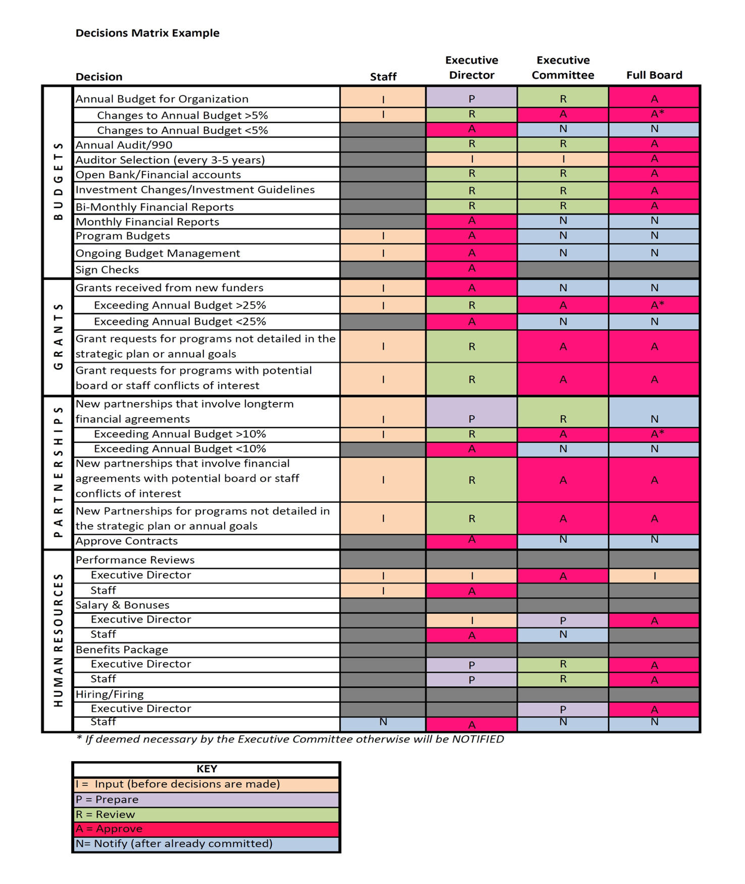

Source: https://creationincommon.com/takeaway-decisions-matrix/

References and Videos

BoardSource

Choosing a Nonprofit Board Video

What is the Most Important Role of Nonprofit Board Members Video?

How to Run an Effective Nonprofit Board Meeting

Best Practices for Non-profit Board Governance Webcast

Video: Nonprofit Mission Statements vs. Vision Statements

