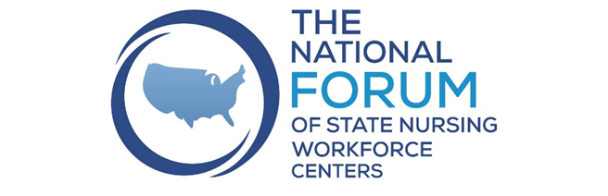
Nurse Well-being and the Workforce
Sharing Session
May 20, 2022

Participants: Jana Bitton, Andrea Bresnahan, Laura Reichhardt, Rayna Letourneau, Patricia Moulton Burwell, Yetty Shabo
- Hawaii- Pre-clinical group therapy using an app that is anonymous using avatars, price is $1.25/month/person, 10-15 minute sessions https://www.dropbox.com/s/1fs4rxn6be6pkcm/nurse-staffing-think-tank-recommendation.pdf?dl=0 Could the National Forum negotiate a deal for all centers that could adopt at their state- could help facilitate state adoption
https://www.evenhealth.com/ . Also see attachment with slides on this program.
One of our facilities are hiring psychologists to round on floors for staff, it’s an EAP benefit that is dedicated to nurses that is brand new. Another has EAP psych at every new grad meeting (monthly)
- Florida- Pilot Project offering behavioral intervention to nursing students and nurses to provide small group coaching. Using ICF trained coaches providing the service. Seems like there might be barriers with students and nurses having difficult finding the time.
- North Dakota- Have developed a Workplace Culture Designation Program Pilot Program- all pilot sites quit the program- just too much going on. Also had multiple issues getting nurses to participate in surveys, focus groups, watch webinar etc. Are looking at pivoting for the future.
Have done some thinking about using Resilient Option- online resiliency resources and training,
- Oregon- RN Well-being project- started at beginning of COVID pandemic. Participation rate is low with nurses. Oregon legislature funded a well-being program for all health care providers and concerned that it would not be utilized by nurses. Found counselors don’t want to provide EAP counseling due to the reimbursement rate and participants don’t want to be seen getting help.
- Massachusetts- working on figuring out where to put funding for nursing efforts, looking at peer support systems within facilities and building these relationships
- Compassionomics-The Revolutionary Scientific Evidence that Caring Makes a Difference https://www.compassionomics.com/
- We are hearing staffing ratios/ being understaffed is a bigger need than “stress management “. It gets closer to the root cause. Having too many patients for too long has led to more burnout.
- Nurses are the profession less likely to have a friend at work.
- Need to think about the concept of trauma informed care and training of nurses and administrators. Don’t know of any resources for this, especially something already developed and including continuing education credits.
What would be helpful for National Forum Members on this Topic:
- A list of resources for workplace culture and available trainings
- Compile reports from the states working on this and the contact for them
- Could develop a work group on this topic to help accumulate resources on this topic and develop further that could be done. Track evidence as everything evolves.

